**Scientific Inquiry & the Pendulum Lab**

**Directions:**

Use this template (outline) to complete steps 5-7 of the scientific method

Headings are in **bold** & instructions are in *italics*

**Analyze Data**

*Insert your data into the data table. Create a title for the table. (title 2 points; content 18 pts)*

*Insert your graph below the data table*

Table 1. Effect of string length on the time period of a pendulum (30 points)

| **Manipulated Variable** | **Trial** | **Time for 10 swings** | **Period of 1 swing** | **Average Period** |
| --- | --- | --- | --- | --- |
| String length 12 cm | 1 | 9.85 seconds | 0.985 seconds | 0.97 seconds |
| 2 | 9.53 seconds | 0.953 seconds |
| 3 | 9.90 seconds | 0.99 seconds |
| String length 27 cm | t | 12.78 seconds | 1.278 seconds | 1.26 seconds |
| 2 | 12.41 seconds | 1.241 seconds |
| 3 | 12.62 seconds | 1.262 seconds |
| String length 43 cm | 1 | 15.69 seconds | 1.569 seconds | 1.57 seconds |
| 2 | 15.69 seconds | 1.569 seconds |
| 3 | 15.81 seconds | 1.581 seconds |

| **5. Analyzing the results** | **You will make a graph**  **What will be on the x-axis?**  **What will be on the y-axis?**  **What type of graph will you make?** | **The string length and the mass of the object bar something etc.**  **Line graph** |
| --- | --- | --- |
| **Analyze Observations:**  **Quantitative Observations: put these in a data table**  **Qualitative Observations: (what else did you observe)** | **I observed each of the string lengths had different speeds and since they also went at different distances it was very quantitative.**  **I observed that at different lengths of the string length it went at different speeds than the other lengths and distances.** |
| **Identify Errors and limitations- what might have caused errors in measurement? What limited your ability to collect accurate and precise data?** | **We did not have a high enough surface the first few times so we did a bunch of other options till we found the one.** |

Figure 1. Effect of string length on the time period of a pendulum 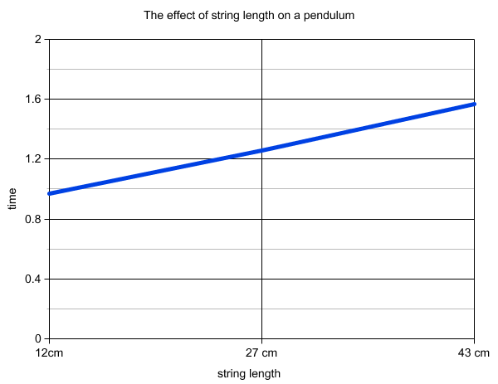

***Graph Grading:***

*Title (2 points); axes labels with units (2 points each); no data labels (2 points); data entered and graphed correctly (9 points)*

| **6. Drawing conclusions &**  **7.Communicating results** | | **Paragraph Assignment- on separate document LAB pendulum paragraph** |
| --- | --- | --- |